**INTELLIGENT ADMISSION:THE FUTURE OF**

**UNIVERSITY DECISION MAKING WITH**

**MACHINE LEARNING**

**TEAM ID: NM2023TMID25291**

**TEAM LEADER :**

**ELAKKIYA D(801FE9D1A4DBC2293904C8D29893B686)**

**TEAM MEMBERS:**

**AMMU K (89533DD5A9A47D2A94643D5CA65B341D)**

**ANUSUYA K(AF01A5797DFEEAD87D44CD3F5B2C9C2B)**

**BARANI S(7DB365792E3F91191CC45215F357AAA1)**

|  |  |  |
| --- | --- | --- |
| **1.** | **INTRODUCTION** |  |
|  | **1.1 Overview** |  |
|  | **1.2 Purpose** |  |
| **2.** | **Problem Definition & Design Thinking** |  |
|  | **2.1 Empathy Map** |  |
|  | **2.2 Ideation & Brainstorming Map** |  |
| **3.** | **RESULT** |  |
| **4.** | **ADVANTAGES & DISADVANTAGES** |  |
| **5.** | **APPLICATIONS** |  |
| **6.** | **CONCLUSION** |  |
| **7.** | **FUTURE SCOPE** |  |
| **8.** | **APPENDIX** |  |
|  | **A. Source Code** |  |
|  |  |  |

**INTRODUCTION:**

**1.1 Overview**

University admission is the process by which students are selected to attend a college or university. The process typically involves several steps, including submitting an application, taking entrance exams, and participating in interviews or other evaluations.

Students are often worried about their chances of admission in University. the university admission ocess for students can be demanding, but by being well-informed, prepared, and organized, students can increase their chances of being admitted to the university of their choice.

The aim of this project is to help students in short listing universities with their profiles. Machine learning algorithms are then used to train a model on this data, which can be used to predict the chances of future applicants being admitted. With this project, students can make more informed decisions about which universities to apply to, and universities can make more efficient use of their resources by focusing on the most promising applicants.The predicted output gives them a fair idea about their admission chances in a particular university. This analysis should also help students who are currently preparing or will be preparing to get a better idea.

**1.2 Purpose:**

This article was an early beta test. See all-new collaborative articles about [Machine Learning](https://www.linkedin.com/showcase/skills-machine-learning/posts/?feedView=articles&viewAsMember=true) to get expert insights and join the conversation.

Machine learning has become an increasingly popular tool in recent years, given its ability to automatically detect patterns in data and make predictions about future events. This can be extremely useful for making decisions in a wide range of domains, from financial trading to medical diagnoses. Here are some ways in which machine learning can be used to improve decision making.

1. **Providing better information**:

Since machine learning technology can sift through extremely large amounts of data, it is able to also provide better information to decision makers. For example, imagine you are a doctor trying to diagnose a patient. If you have access to a machine learning algorithm that can automatically analyze a patient's medical history and make predictions about which diseases they are likely to have, you will be able to make much better decisions about how to treat them.

“It takes time and doctor’s visits and clinical testing to gather sufficient data that paints a comprehensive picture of a patient’s health. The problem is that often, all doctors know about the patient sitting in front of them is what they’ve actively discussed with that patient. [...] [The machine learning] process gives doctors the chance to assess conditions they might not have otherwise considered and also flags potential care gaps for closure, for example that a patient is overdue for a preventive screening or hasn’t been taking their medication.”

[Andrew Toy](https://www.linkedin.com/in/toyand/) is the president of health technology company Clover Health. He holds over 20 years of experience in the tech industry. He earned a masters in computer science from Stanford University.

1. **Automating the process**:

In many industries, it is simply not possible for human beings to make optimal decisions all of the time. This is especially true in industries where the data is constantly changing, such as financial markets. In these cases, machine learning algorithms can be used to automatically make decisions as trends change and evolve.

“There is enough data and technology to tremendously reduce manual work in the mortgage industry. Take machine learning. We [...] use an NLP algorithm that goes through hundreds of pages of scanned and almost unreadable documents and extracts the crucial project information in minutes. This means days are saved on each condo project for lenders. This brings us back to customer experience and added value. Less time going through the paperwork gives more time to provide a great experience for the borrower.”

[Atin Hindocha](https://www.linkedin.com/in/atinhindocha/) is the co-founder of real estate technology company InspectHOA. He holds over 10 years of experience in the tech industry and earned his masters in strategy and technology from the University of Washington.

1. **Improving accuracy**:

By identifying patterns in data that humans may not be able to see, machine learning can drastically improve the accuracy of its predictions. It can also create models that simulate different decision scenarios and help identify the best course of action. And as new data becomes available, machine learning can be used to constantly update and refine decision models.

**Problem Definition & Design Thinking**

**Empathy Map:**

An empathy map is a collaborative visualization used to articulate what we know about a particular type of user. It externalizes knowledge about users in order to 1) create a shared understanding of user needs, and 2) aid in decision making.

This article is a guide to empathy mapping and its uses.

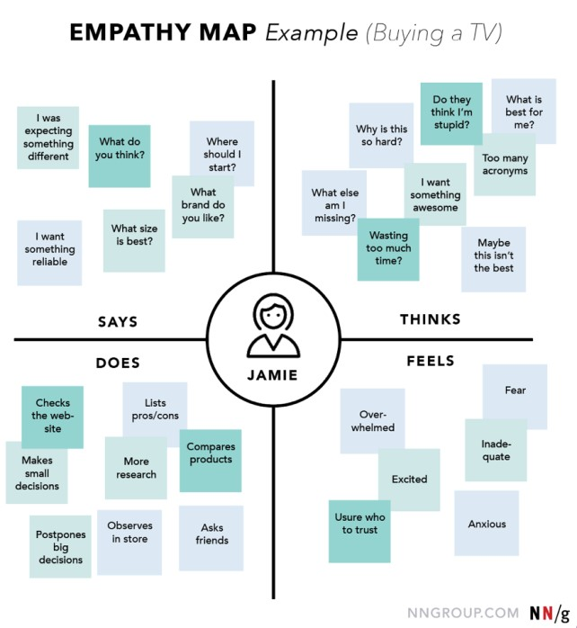

**1.Define scope and goals:**

1. What user or persona will you map? Will you map a persona or an individual user? Always start with a 1:1 mapping (1 user/persona per empathy map). This means that, if you have multiple personas, there should be an empathy map for each.
2. Define your primary purpose for empathy mapping. Is it to align the team on your user? If so, be sure everyone is present during the empathy-mapping activity. Is it to analyze an interview transcript? If so, set a clear scope and timebox your effort to ensure you have time to map multiple user interviews.
3. **Gather materials:**

Your purpose should dictate the medium you use to create an empathy map. If you will be working with an entire team, have a large whiteboard, sticky notes, and markers readily available. (The outcome will look somewhat like the illustration above.) If empathy mapping alone, create a system that works for you. The easier to share out with the rest of the team, the better.

1. **Collect research:**

Gather the research you will be using to fuel your empathy map. Empathy mapping is a qualitative method, so you will need qualitative inputs: user interviews, field studies, diary studies, listening sessions, or qualitative surveys.

1. **Individually generate sticky notes for each quadrant:**

Once you have research inputs, you can proceed to mapping as a team. In the beginning, everybody should read through the research individually. As each team member digests the data, they can fill out sticky notes that align to the four quadrants. Next, team members can add their notes to the map on the whiteboard.

1. **Converge to cluster and synthesize:**

In this step, the team moves through the stickies on the board collaboratively and clusters similar notes that belong to the same quadrant. Name your clusters with themes that represent each group (for example, “validation from others” or “research”). Repeat themes in each quadrant if necessary. The activity of clustering facilitates discussion and alignment — the goal being to arrive at a shared understanding of your user by all team members.

Once your empathy map is clustered, you can begin to vocalize and align as a team on your findings. What outliers (or data points that did not fit in any cluster) are there? What themes were repeated in all the quadrants? What themes only exist in one quadrant? What gaps exist in our understanding?

1. **Polish and plan:**

If you feel that you need more detail or you have unique needs, adapt the map by including additional quadrants (like Goals the example below) or by increasing specificity to existing quadrants. Depending on the purpose of your empathy map, polish and digitize the output accordingly. Be sure to include the user, any outstanding questions, the date and version number.

Plan to circle back to the empathy map as more research is gathered or to guide UX decisions. **2.2 Ideation & Brainstorming Map**

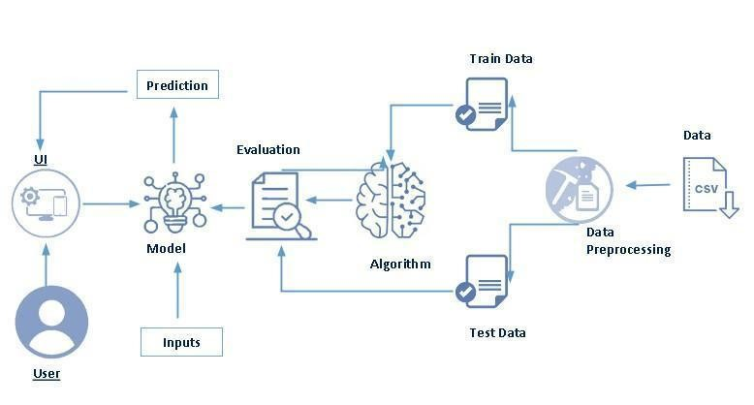

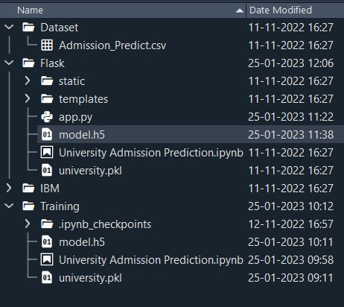

**RESULT:**

Through this educational model, the students can guide their own learning. They can have their own pace and can make decisions about what to learn and how to learn. They can choose the subjects they are interested in, the teacher they want to learn from and what curriculum, standards and pattern they want to follow.

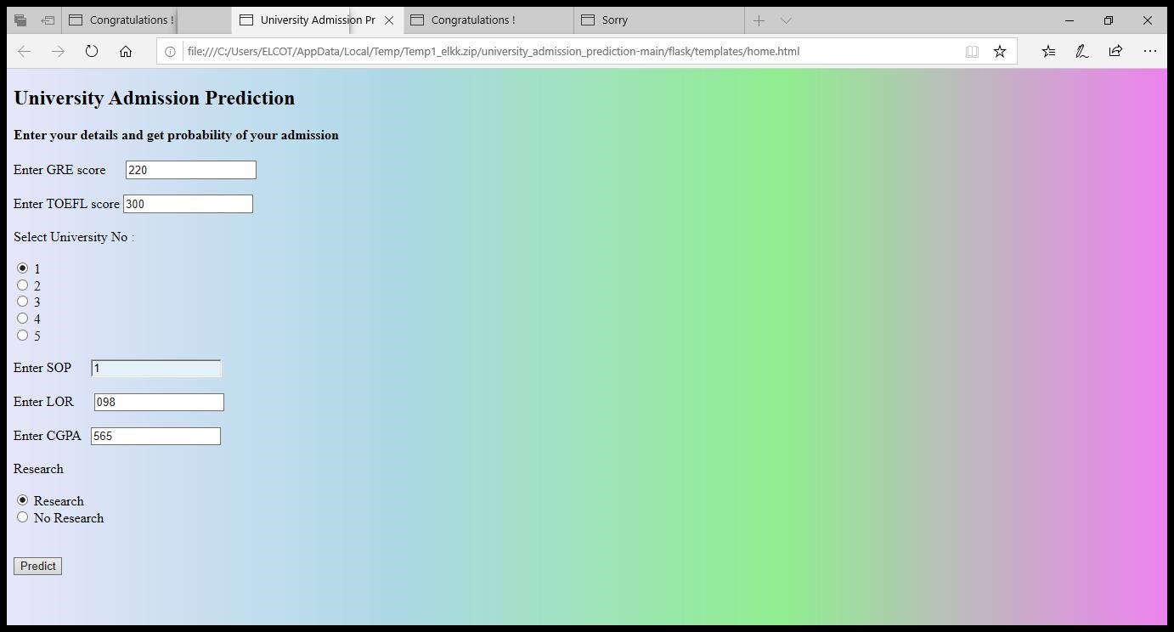

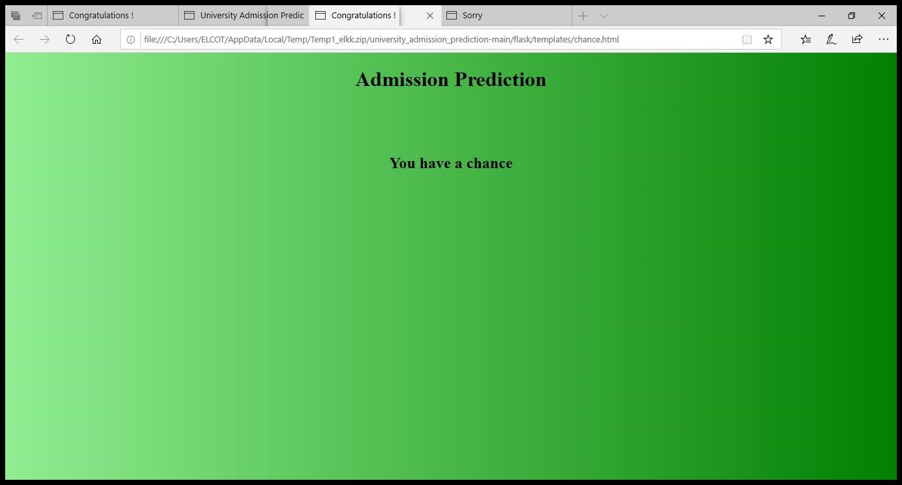

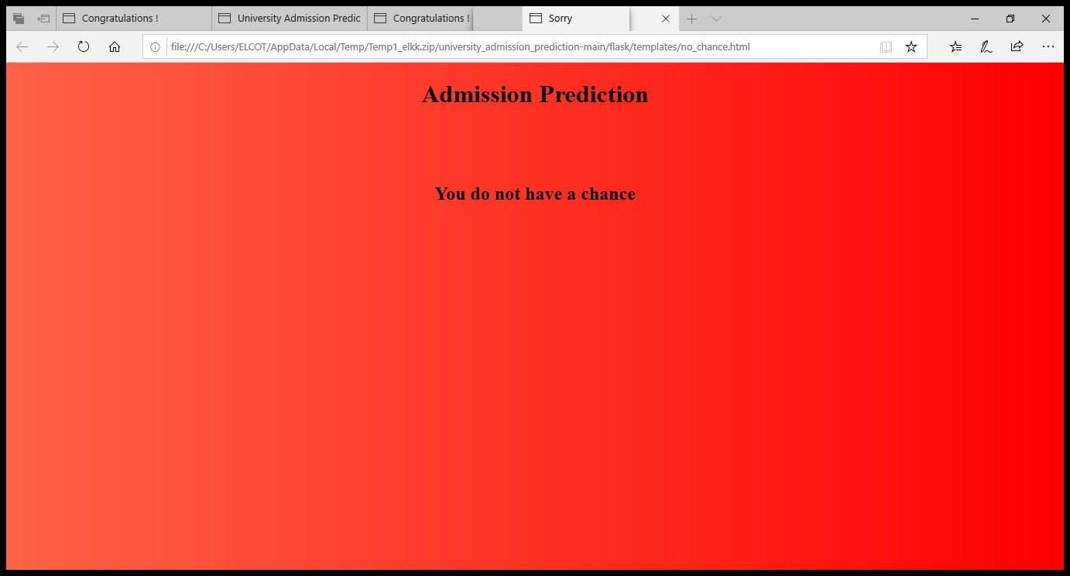

**ADVANTAGE:**

Quick Identification of Trends and Patterns

It is automatic and does not require human interference

Continual Development

Adoption by Multi-industries

**Quick Identification of Trends and Patterns:**

Machine learning can evaluate massive amounts of data and find precise patterns and trends that people might overlook. For Instance, e-commerce sites like Amazon are enabled with information on their customers' purchasing patterns and history which helps in recommending them the appropriate goods, discounts, and reminders. It makes use of the information to present consumers with pertinent advertisements.

A machine can gain knowledge more as it accumulates data, and as it accumulates data, it also learns patterns and trends. Consider how social networking sites like Facebook or Instagram function. The data of the users' interests and browsing history are recorded and understood through patterns that are then displayed to them to maintain their interest in the same app. Machine learning assists in recognizing trends and patterns in this way.

It is automatic and does not require human interference

Machine learning equips computers with the ability to carry out the entire data interpretation and analysis process on its own. There is no need for you to supervise your project at every stage. Take for example how anti-virus programs work. They learn to filter new threats upon identification.

For the prediction or interpretation of the results, no human interaction is necessary. The entire machine learning process begins with machine learning and anticipating the algorithm or program that will produce the best outcome. Another example is Google Home, which recognizes voice commands and then determines the desired outcome for the user.

**Continual Development:**

With experience and more operations, Machine learning gain effectiveness and accuracy. They can consequently make wiser selections. Take the example of creating a weather forecast model. With the expansion of your data, the predictions become more accurate and the algorithm speeds up in producing the predictions.

Handles data with several dimensions and variants

A machine learning algorithm is capable of managing multivariate and multidimensional data even in the most uncertain contexts and dynamic situations. It can manage a range of facts even in a hazy and unpredictable environment. It is both multifaceted and multitasking.

**Adoption by Multi-industries:**

Machine learning is employed in a variety of industries, including education, medicine, engineering, and other areas of daily life. ranging from a very modest application to very large and complex structured machines that aid in data analysis and prediction. It not only turns into a healthcare provider but also offers prospective clients more individualized services.

**DISADVANTAGE:**

Data Acquisition

Time and Resources Intensive

Chances of faulty Interpretation of data

Requirement of more Space **Data Acquisition:**

Machine learning mandates the need for large, unbiased, comprehensive, and high-quality data sets for training. They are sometimes required to stand by for new data generation. For better forecasting or decision-making with Machine Learning, a computer needs to be fed with more data since the more data it receives, the more accurate and effective it becomes. But occasionally, it might not be achievable. Additionally, the information must be accurate and neutral. Data requirements can be challenging at times.

**Time and Resources Intensive:**

For machine learning (ML) to be effective, the algorithms must have enough time to mature and learn enough to achieve their goals with a high degree of accuracy and relevance. This could result in you needing more processing power from your machine. The machine may occasionally take a long time to learn because efficacy and efficiency can only be attained via experience, which again takes time. In addition, it is challenged by the need for more resources to run, for instance more computers.

**Chances of Faulty Interpretation of data:**

The capacity to correctly comprehend the information produced by the algorithms presents one of the significant disadvantages of machine learning. Although autonomous, machine learning is prone to mistakes. Consider training an algorithm with data sets that are too tiny to be inclusive. You obtain biased predictions from a biased training set in the end. This results in customers seeing irrelevant advertisements. Such flaws in ML can start a cascade of mistakes that may be undiscovered for a very long time. Moreover, it takes time to identify problems and even longer to find remedies. Sometimes data that is error-free can nonetheless be interpreted incorrectly by a machine because the data it was given may not have met all of its requirements.

**Requirement of More Space:**

More storage capacity is needed because more data is needed for interpretation, which is one of the biggest disadvantages of machine learning. It takes a lot of storage space to handle or keep data for further decision-making because more data means the computer has more information or material to learn from.

**APPLICATIONS:**

1.Social Media Features:

Social media platforms use machine learning algorithms and approaches to create some attractive and excellent features. For instance, Facebook notices and records your activities, chats, likes, and comments, and the time you spend on specific kinds of posts. [Machine learning](https://www.simplilearn.com/tutorials/machine-learning-tutorial/introduction-to-machine-learning) learns from your own experience and makes friends and page suggestions for your profile.

1. Product Recommendations:

Product recommendation is one of the most popular and known applications of machine learning. Product recommendation is one of the stark features of almost every e-commerce website today, which is an advanced application of machine learning techniques. Using [machine learning and AI,](https://www.simplilearn.com/artificial-intelligence-ai-and-machine-learning-trends-article) websites track your behavior based on your previous purchases, searching patterns, and cart history, and then make product recommendations.

1. Image Recognition:

Image recognition, which is an approach for cataloging and detecting a feature or an object in the digital image, is one of the most significant and notable machine learning and AI techniques. This technique is being adopted for further analysis, such as [pattern recognition,](https://www.simplilearn.com/pattern-recognition-and-ml-article) face detection, and face recognition.

1. Sentiment Analysis:

Sentiment analysis is one of the most necessary applications of machine learning. Sentiment analysis is a real-time machine learning application that determines the emotion or opinion of the speaker or the writer. For instance, if someone has written a review or email (or any form of a document), a sentiment analyzer will instantly find out the actual thought and tone of the text. This sentiment analysis application can be used to analyze a review based website, decisionmaking applications, etc.

1. Automating Employee Access Control:

Organizations are actively implementing machine learning algorithms to determine the level of access employees would need in various areas, depending on their job profiles. This is one of the coolest applications of machine learning.

1. Marine Wildlife Preservation:

Machine learning algorithms are used to develop behavior models for endangered cetaceans and other marine species, helping scientists regulate and monitor their populations.

1. Regulating Healthcare Efficiency and Medical Services:

Significant healthcare sectors are actively looking at using machine learning algorithms to manage better. They predict the waiting times of patients in the emergency waiting rooms across various departments of hospitals. The models use vital factors that help define the algorithm, details of staff at various times of day, records of patients, and complete logs of department chats and the layout of emergency rooms. Machine learning algorithms also come to play when detecting a disease, therapy planning, and prediction of the disease situation. This is one of the most necessary machine learning applications.

1. Predict Potential Heart Failure:

An algorithm designed to scan a doctor’s free-form e-notes and identify patterns in a patient’s cardiovascular history is making waves in medicine. Instead of a physician digging through multiple health records to arrive at a sound diagnosis, redundancy is now reduced with computers making an analysis based on available information.

1. Banking Domain:

Banks are now using the latest advanced technology machine learning has to offer to help prevent fraud and protect accounts from hackers. The algorithms determine what factors to consider to create a filter to keep harm at bay. Various sites that are unauthentic will be automatically filtered out and restricted from initiating transactions.

1. Language Translation:

One of the most common machine learning applications is language translation. Machine learning plays a significant role in the translation of one language to another. We are amazed at how websites can translate from one language to another effortlessly and give contextual meaning as well. The technology behind the translation tool is called ‘machine translation.’ It has enabled people to interact with others from all around the world; without it, life would not be as easy as it is now. It has provided confidence to travelers and business associates to safely venture into foreign lands with the conviction that language will no longer be a barrier.

**CONCLUSION:**

In conclusion,the Intelligent Admission: the future of university decision making with Machine Leraning has shown that the application of machine learning algorithm can show the in Intelligent admission for the student in university

**FUTURE SCOPE:**

Machine learning uses statistical patterns to make accurate predictions. The technology is also helpfull in document analysis, fraud detection, KYC processing, high-frequency trading, etc. It is the future scope of machine learning which is scouring the banking sector.

**APPENDIX**

**Source code**

FLASK:

import numpy as np from flask import Flask, request, jsonify, render_template import pickle app=Flask(__name__)

#import necessary libraries from tensorflow.keras.models import load_model #model = pickel.load(open('university.pkl','rb'))

